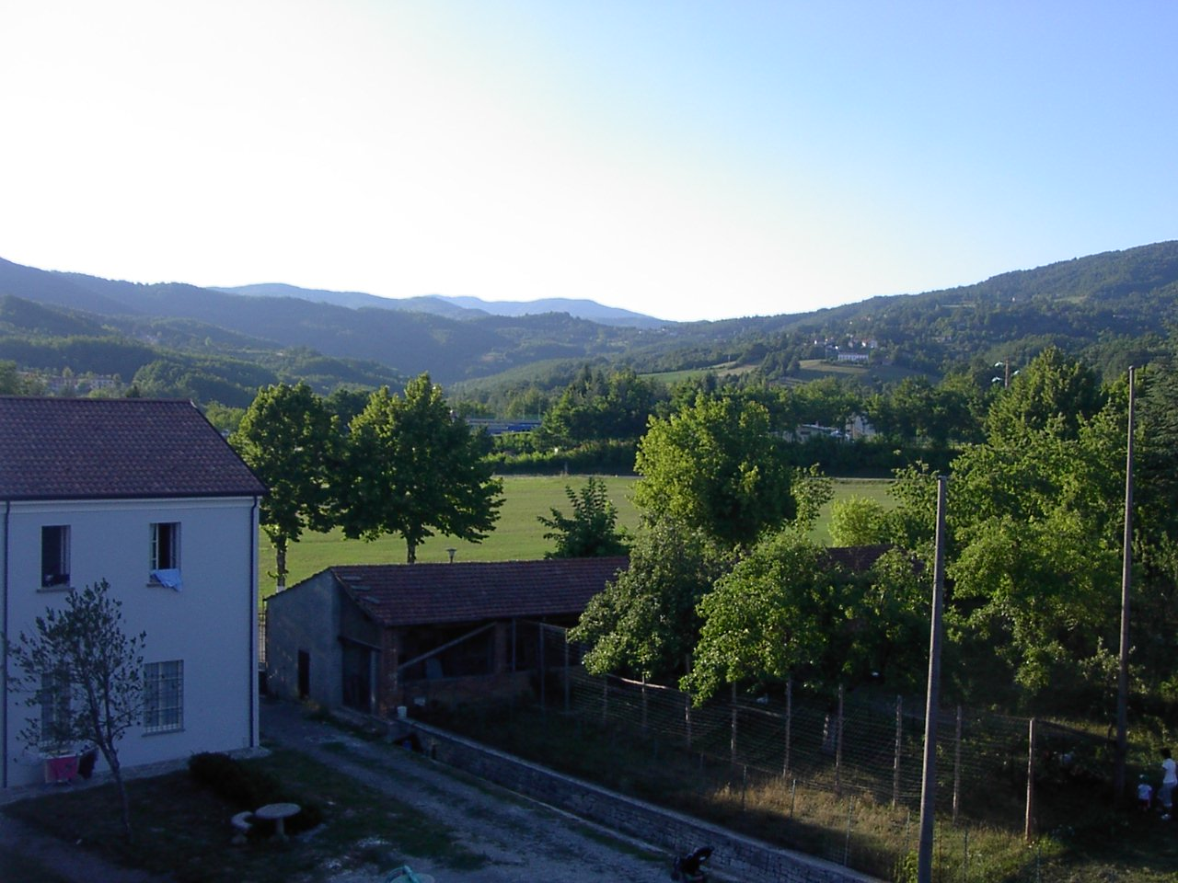

Antipasti

Starters

Bruschetta (V) £4 . 25

Southern Italian garlic bread topped with
freshly crushed tomato, olive oil, oregano and
fresh basil.

Zuppa £3 . 40

Freshly made soup of the day.

Carpaccio Parma £8 . 65
Thin layers of Parma ham, wild rocket,
olive oil, lemon and parmesan shavings.

Cozze £9 . 20

Fresh mussels sautéed with garlic and white
wine, served in a spicy tomato sauce with crostini.

Mozza Roccoco (V) £7 . 75

Fresh baby mozzarella cheese with slow roast
peppers, wild rocket and rocket pesto dressing.

Calamari Fritti £7 . 75

Deep fried squid rings.

Rollo di Sa;mone e Gambaretti £7 . 65

Smoked salmon, prawns and champagne with

lemon in a cream cheese mousse, wrapped in
smoked salmon.

Tritico di Pesce Affumicato £7 . 40

Thinly sliced smoked salmon, swordfish and

Haddock served with wild rocket and lemon juice

Crostini alla Siciliana £5 . 35

Crispy Italian bread topped with pesto
and Parma ham.

Affettato Misto £6 . 30
A selection of cured Italian meats

Antipasto di Mare £7 . 80

A selection of cold seafood prawns, squid
and mussels tossed in a lemon and olive oil dressing.

Capesanti al Vino Bianco £8 . 15
King scallops wrapped in Parma ham, sautéed in
white wine and garlic, served with crostini.

Avocado Gamberetti £6 . 70£

Avocado and prawns topped with a marie rose sauce.

Prosciutto e Melone £6 . 60

Melon and Parma ham.

Involtini di Melenzane £7 . 10
Aubergines stuffed with mozzarella and ham,
oven baked with tomato and béchamel sauce

Pane al aglio con olive (V) £4 . 30

Hot garlic bread served with marinaded olives.

Peperoncini Ripieni £6 . 10

Sweet cherry chilli peppers stuffed with cream cheese.

