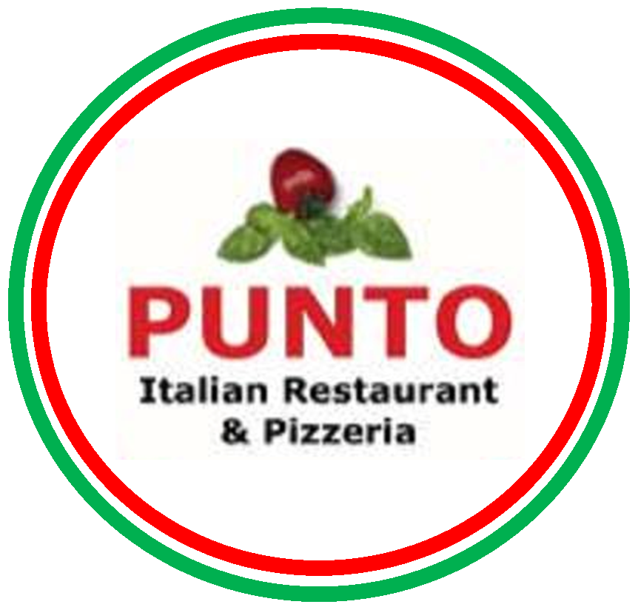

STARTER

GARLIC BREAD…………………………………………………………………2.75
GARLIC BREAD ………………………………………………………………...3.00
With tomato
GARLIC BREAD…………………………………………………………………3.25
With cheese
GARLIC BREAD…………………………………………………………………3.95
With tomato and cheese
GARLIC BREAD FANTASIA…………………………………………………..5.95
Pizza bread topped with mixed grill vegetables, tomato, garlic and smoked cheese.

MIX SALAD……………………………………………………………….……...2.95

SUP OF THE DAY………………………………………………………………...450

MINESTRONE……………………………………………………………………4.50
Vegetable soup

PARMA HAM AND MELON…………………………………………………...5.95

PAVAROTTI SALAD…………………………………………………………....6.95
Fresh buffalo mozzarella, tomato, avocado, boiled eggs, cocktail prawns on bed of rocket lettuce.

TRICOLORE………………………………………………………………….….5.95
Fresh mozzarella, avocado, tomato and basil.

FUNGHI DON BENI……………………………………………………………5.95
Flat mushroom, smoked cheese, ham, tomato, béchamel, garlic, olive oil, and gratin.

FUNGHI CARTOCCIO……………………………………………………….... 5.95
Two kind of mushrooms, garlic, chilli, parsley, in white wine sauce

COZZE AL POMODORO…………………………………………………….....5.95
Fresh mussels, garlic, olive oil, chilli, white wine in tomato sauce

INSALATA DI MARE……………………………………………………………5.95
Fresh seafood salad.

KING PRAWNS DIAVOLA……………………………………………………..6.95
Mediterranean prawns in garlic, olive oil, chilli, white wine, and spicy tomato sauce

CALAMARI DIAVOLA……………………………………………………….…5.95
Fresh squid in garlic, olive oil, in spicy tomato sauce.

CROSTINE MARE…………………………………………………………….…6.95
Toasted bread mozzarella cheese, smoked salmon, seafood, tomato and cream.

ANTIPASTO FOR TWO……………………………………..…. 12.95
Marinated vegetables with an Italian selection of cold cured meats, boiled eggs,avocado and cocktail prawns.

SARDINES ALLA GRIGLIA…………………………………………………...5.95
Fresh grilled sardines served with salad and lemon.

BRESAOLA……………………………………………………………………….7.95
Cold cured beef with Parmesan, olive oil and lemon

PASTA

SPAGHETTI NAPOLI……………………………………………………….…5.95
Spaghetti pasta garlic, olive oil, basil, fresh tomato and tomato sauce.

SPAGHETTI BOLOGNESE…………………………………………….…..…..6.95
Spaghetti pasta with meat, béchamel and tomato sauce

SPAGHETTI CARBONARA……………………………………………………7.95
Spaghetti pasta, Italian bacon yolk eggs and Parmesan cheese.

SPAGHETTI CARTOCCIO………………………………………………….….8.95
Spaghetti pasta, mixed seafood, king prawns, langoustine, mussels, squids, white wine garlic, chilli and tomato sauce.

SPAGHETTI alle VONGOLE……………………………………………….….8.95
Spaghetti pasta olive oil, chilli, fresh clams, chopped tomato, white wine and parsley.

SPAGHETTI KING PRAWNS…………………………………………………9.95
Spaghetti pasta, king prawns, garlic, white wine, chilli and tomato sauce.

SPAGHETTI MARE MONTI………………………………………………...…9.95
Spaghetti pasta, baby lobster, king prawns, mussels, squid, clams, mushrooms, spinach, white wine, vegetable and garlic sauce.

PENNE ARRABIATA………………………………………………………….6.95
Penne pasta garlic, olive oil, chilli, fresh tomato parsley and tomato sauce.

PENNE PASTICCIATA………………………………………………..……...7.95
Penne pasta, Italian bacon, onions, green peas, mushrooms. cream in tomato sauce.

FETTUCCINE DON BENI…………………………………………………….7.95
Fettuccine pasta with selection of forest and Sylvester mushrooms in cream and tomato sauce.

FETTUCCINE AL ARAGOSTA………………………………………………10.95
Fettuccine pasta half lobster, olive oil, garlic, chilli, white wine, fresh tomato and tomato sauce.

RIGATTONI ALLA MATRICANA…………………………………………....6.95
Tube pasta in onion, Italian bacon, garlic, olive oil, chilli and tomato sauce.

RIGATTONI AL TUNA………………………….………….………………..…6.95
Tube pasta, onions, garlic, black olives, and tuna in tomato sauce.

RIGATTONI AURORA GRATIN ………………………………..…………….6.95
Tube pasta, ham, mushrooms, onions, tomato sauce topped with Parmesan and mozzarella cheese, gratin.

RISOTTO AI FUNGHI…………………………………………………………7.95
Rice, selection of mushrooms, cream and tomato sauce.

RISOTTO AI FRUTTI DI MARE……………..………………………………7.95
Rice, kink prawns, langoustine, squids, mussels, mixed seafood in tomato sauce.

RISOTTO SUPER MARE MONTI……………………………………………..9.95
Rice, baby lobster, king prawns, mussels, clams, squids, fresh salmon, mushroom, spinach, vegetable sauce, and white wine

RISOTTO AL SALMONE………………………………………………………7.95
Rice, chopped fresh tomatos, onions, spinach, cream and tomato sauce.

GNOCCHI……………………………………………………………………..…6.95
Dumplings potato pasta, basil, blu cheese, cream and tomato sauce.

TORTELLONI MAMMA ROSA………..………………………………………7.95
Fresh pasta filled with ricotta cheese, spinach in tomato sauce, cream, basil, garlic, chopped tomato.

LASAGNA GRATIN……………………………………………………………..6.95

MELANZANA alla PARMIGIANA…………………………………………….6.95
Aubergines, basil, garlic, olive oil, cheese, in tomato sauce, gratin.

MAIN COURSES

CHICKEN BREAST

POLLO PUNTO…………………………………………………………..…12.95
Breast of chicken topped with ham, mozzarella, basil, garlic, tomato and cream sauce.

POLLO PASTICCIATO………………………………………………………..12.95
Breast of chicken with Italian bacon, green peas, cream and tomato sauce.

MEAT

BISTECCA AL PEPE VERDE…………………………………………………13.95
Sirloin steak cooked with green peppercorn, brandy, butter, and cream sauce.

BISTECCA TRE FUNGHI…………………………………………………..…13.95
Sirloin steak in red wine, three kinds of mushrooms in cream sauce.

STINCO AL FORNO……………………………………………………………13.95
Roasted shank of pork in red wine rosemary and butter.

VEAL ESCALOPE

MILANO NAPOLI………………………………………………………..…….13.95
Veal escalope in breadcrumbs, topped with fresh tomato, cheese, basil, and garlic then toasted –served with spaghetti Napoli.

SCALOPPINA SALTINBOCCA……………………………………………13.95
Veal escalope sage, Parma ham in white wine sauce.

F I S H

SALMONE CREMA DI MARE………………………………………………13.95
Salmon steak smoked salmon, mixed seafood, garlic, butter, béchamel and cream sauce.

SPIAGOLA A PIACERE………………………………………………………15.95
Fresh sea bass cooked, as you like it
.

MISTO PESCE DIAVOLA…………………………………………………….16.95
Selection of shellfish, half lobster, king prawns, langoustines, mussels, squid, clams, garlic, olive oil, white wine and spicy tomato sauce.

All main courses come with vegetables included

P I Z Z A S

MARINARA………………………………………………………………………4.95
Tomato, basil, capers, anchovies, garlic sauce (no cheese)

MARGHERITA…………………………………………………………………..5.95
Tomato, mozzarella cheese.

NAPOLETANA…………………………………………………………………..6.50
Tomato, mozzarella, olives, anchovies, capers.

FUNGHI…………………………………………………………………………..6.95
Tomato, mozzarella, and mushrooms.

PROSCIUTTO………………………………………………………………… .6.50
Tomato, mozzarella, ham.

REGINA………………………………………………………………………….7.50
Tomato, mozzarella, ham, mushrooms, black olives
.
AMERICAN……………………………………………………………………7.50
Tomato, mozzarella, peperoni sausage.

AMERICAN HOT………………………………………………………………7.95
Tomato, mozzarella, peperoni sausage, peppers, onion and chilli sauce.

NETTUNO……………………………………………………………………….7.50
Tomato, mozzarella, onions, tuna, olive oil, capers.

FIORENTINA……………………………………………………………………7.50
Tomato, mozzarella, blu cheese, spinach and eggs.

PESCATORA…………………………………………………………………….8.95
Tomato, mozzarella and seafood.

PUGLIESE………………………………………………………………………5.95
Tomato, mozzarella and onion.

COLAZIONE……………………………………………………………………..6.50
Tomato, mozzarella, bacon, eggs.

DON BENI………………………………………………………………………..8.95
Tomato, mozzarella, mushrooms, peperoni sausage, olives, artichokes, eggs, Parma ham.

QUATTRO FORMAGGI………………………………………………………...7.50
Mozzarella, Parmesan, blu cheese, smoked cheese. (No tomato)

QUATTRO STAGIONI ………………………………………………………….7.50
Tomato, mozzarella, -peperoni sausage, olives, mushrooms, artichokes.

PARMIGIANA……………………………………………………………………7.50
Tomato, mozzarella, aubergines, Parmesan and basil.

VEGETARIANA………………………………………………………………….7.50
Tomato, mozzarella, Parmesan, onions, artichokes, mushrooms, spinach, olives, peppers.

HAWAIIANA……………………………………………………………………..7.50
Mozzarella, pineapple and ham

CALZONE… (Folded pizza)…………………………………………………......8.95
Tomato, mozzarella, blu cheese, mushrooms and ham

CALZONE …(Folded pizza)………………………………………9.95
Tomato, mozzarella, artichokes, olives, peperoni sausage, mushrooms, boiled eggs, served with garlic and Parma ham.

PRIMAVERA……………………………………….………...…………………..6.95
Tomato, mozzarella, oregano, two eggs, and asparagus.

KING PRAWNS PIZZA…………………………………………………………9.95
Tomato, mozzarella, 6 king prawns, in garlic.

RUCOLA………………………………………………………………………….8.95
Tomato, mozzarella, rocket lettuce, Parmesan and parma ham.

OTTELLA…………………………………………………………………………9.95
Tomato, mozzarella, king prawns, langoustine, mussels, mix seafood.

CAMPAGNOLA…………………………………………………………………8.95
Mozzarella, mixed grill vegetables, smoked cheese (no tomato)

