
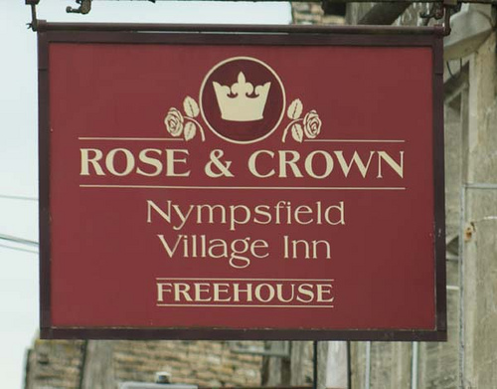

Our food is homemade and sourced from excellent British suppliers
Char-grill Steaks & homemade Burgers…

Lunch @

Mon-Sat 12.00 – 2.30pm

SANDWICHES
Ciabatta or Focaccia bread
served with mixed leaves
All £4.95

Tomato, pesto,
buffalo mozzarella,
aged balsamic & basil (v)

Cheese & pickle,
mixed leaves, tomato & red onions (v)

Bacon, lettuce & tomato

Gloucestershire Sausages & red onion

Crispy Bacon, Brie & caramelised red onion

Home beer battered Fish Goujons with chive tartar

Hunters Chicken
(chicken goujons, bacon, bbq sauce, melted mozzarella & mixed leaves) £5.95

Rose & Crown Hog roast loin of pork, stuffing & chunky apple sauce £5.95

Gloucestershire mature roast Sirloin of Beef & red onions with horseradish mayo £6.95

Add chips to your sandwich for a £1.00

See boards
For today’s
Specials

10o/z Sirloin…Aged mature Gloucestershire steak, 14.50
(Served with roasted new potatoes or chips with a selection of seasonal vegetables or baby mixed leaves)
Madeira sauce or Peppercorn sauce 2.00

Char-grilled Chicken supreme, vine on cherry tomatoes 10.95
(Served with roasted new potatoes or chips with a selection of seasonal vegetables or baby mixed leaves)

10o/z Gammon steak with eggs, 9.95
vine on cherry tomatoes, chips & mixed leaves

Homemade Venison burger, 10.50
Caramelised red onion & beetroot, sliced tomato, crispy onion rings & chips

Homemade Beef burger, 9.50
crispy bacon, mayo, sliced tomato and cheddar cheese

Cajun spiced Chicken breast, mayo & sliced tomato 9.95

Baked Halloumi cheese burger, coated with basil pesto & sliced tomato (v) 9.50
Meat & two Veg…
Gressingham Duck breast, with a blackcurrant sauce 13.95
(Served with roasted new potatoes or chips with a selection of seasonal vegetables or baby mixed leaves)

Today’s homemade Pie, served with creamy mash & seasonal vegetables 10.50

Hand made Gloucestershire Pork Sausages & colcannon mash, 9.95
red onion & blood pudding gravy (blood pudding optional) & crackling

Stuffed Portabella mushrooms, with cream cheese, spinach & pine-nuts (v) 9.95
(Served with roasted new potatoes or chips with a selection of seasonal vegetables or baby mixed leaves)

Todays Pasta, (please see our special board or ask your server) (v) From 9.95
Fish & Chips…
All our fish is from sustainable and under utilised stocks & is freshly beer battered to order
Fish Goujons, chive tartar & dressed baby mixed leaves (add chips for a £1.00) 5.95

Beer battered Cod & chips, chive tartar & garden peas 10.50

Luxury Fish Pie, w/ creamy mash, severed with a seasonal vegetables or mixed leaves 11.95

Salmon supreme, baby spinach, sun dried tomato focaccia herb crust and hollandaise sauce 12.50
Green & wild…
Seared Scallops, smoked bacon & black pudding salad 13.95
A fantastic warm salad, bursting with flavours, Meaty scallops, sautéed with bacon lardoons and rich black pudding

Warm Mushroom & Prosciutto ham salad with Poached egg 11.50
This delicious warm salad is the perfect choice for a healthier and satisfying dish

Sweet Chilli Chicken salad, mixed leaves, cucumber, tomatoes, red onions & peppers 9.95
mixed leaves, cucumber, tomatoes, red onions & peppers

Greek Salad mixed leaves, cucumber, tomatoes, red onions, olives & feta cheese (v) 8.95

Oak smoked Bacon, stilton, new potato & cherry tomatoes salad 8.95
Lite bites & Sides…
Nachos, Home fried tortillas, w/ melted cheese, red onions, sour cream, 5.95
salsa, guacamole & hot peppadew peppers (v)

Quesadilla (spinach, red onion, tomato salsa & cheese) (v) 4.95

Chicken Goujons with bbq & sweet chilli dipping sauce & mixed leaves 5.25

Chips (v) 2.95 Cheesy chips (v) 3.50

Garlic bread (v) 2.70 Garlic bread with mozzarella (v) 2.95
Please be patient with us at busy times. All our food is freshly made to order.(v) – Denotes vegetarian option. Some dishes may contain nuts

